# 

# *The ECME-ACT Trial Project Handbook*

# 

Contact: (Redacted for Blind Review) (10am-6pm, Monday to Friday)

ECME-ACT Training Booklet

## Hello and Welcome!

Thank you for agreeing to take part in this research, and we really hope that you enjoy the experience. The purpose of this booklet is to provide with a training guide to help you get started using the ECME-ACT technology. The training guide is divided into three sections:

1. Using the iPad
2. Using your Devices and the ECME-ACT App
3. Navigating the ECME-ACT App
   1. Daily questions
   2. ACT tips
   3. Mindfulness audios

There are also blank pages at the end of this booklet. This is where you can write comments or feedback, basically anything at all about taking part in this research! You are the experts here and we would be delighted to get your on the technology or therapeutic sessions (e.g. if you don’t like how something works etc.) If you don't have anything to write that's fine too.



Thank you so much for taking part in this research, your participation is invaluable to us and we really hope that you enjoy the experience.

## 1. Using your Ipad

Everyone will have different levels of experience using the iPad. **The following instructions are written from** **the point of view of someone who has never used an iPad before, so if you are an experienced iPad user you may wish to skip to the next section.**

We will keep it very basic and have included pictures so that we can show you what the steps we are describing actually look like.

### Getting Started - The Power Button and the Home Button

The most used and most important buttons on the iPad are the power button and the home button. Once you can locate these buttons, you will be able to easily interact with your iPad. Initially, it is best to find these buttons when the iPad is OFF.

#### Power Button

The power button is located on the edge of the iPad. By using the case provided as a guide, we can easily find it. See the case as a book cover and hold the iPad as you would a book that you were about to open.

In this position, you will find the power button on the top right-hand side of the iPad. If you run your finger across the top of the iPad, you’ll be able to feel it raised. Below is a picture of what it looks like:

|  |
| --- |
|  |

#### Home Button

Open the front cover. You will see the home button located at the bottom centre of the iPad, it will be where you’d expect to find the number at the bottom of a page. Unlike the power button, it is not located on the edge of the iPad, instead it is on the black border that surrounds its screen. It is a circle button that feels like a dip in the screen. Below is a picture of that the Home button looks like.

|  |
| --- |
|  |

### Turning on your iPad

* Place the iPad in front of you as described in the Power Button section, that is, with the case facing you as if it were a book.
* Open the cover
* Press the power button for roughly 3 seconds.
* An Apple logo appears on the screen.

|  |
| --- |
|  |

* After roughly 20 seconds, the apple will disappear.
* You will now be looking at a colourful screen, this is your Home screen.

|  |
| --- |
|  |

### Working the Home Screen.

* On the Home screen, you will be touching the screen of the iPad to make it work instead of pressing buttons along its edge or border.
* It is best to use your case as a stand for your iPad.

#### Pressing the Home Screen

* The best way to press the Home Screen is to use the flat part of your index finger to touch the screen.
* Imagine the part of your finger that you would use to get your finger print taken, or how you would play a key on a piano.

|  |
| --- |
|  |

* You will not have to put a lot of pressure on the screen but feel comfortable giving it a sharp tap.

### 1.4 How to Open & Close an App.

* On the Home screen you will see little boxes, these are called apps (short for application).
* These boxes tell the iPad what to do e.g. to open photographs, to play music, to open the ECMEACT app.
* In order for apps to do this, they need to be opened.
* To open an app, you tap it, as outlined in “Working the Home Screen” above.
* To close the app, press the Home button.
* This brings you back to the Home screen once again.

|  |
| --- |
|  |

### How to Re-Start an App

* Sometimes an app might be taking a while to open or perhaps work like it should. You may need to re-start the app. See it as a way of refreshing it!
* To do this, press the home button twice in quick succession.
* You will be presented with a screen that looks like the picture below. It contains all the apps that are currently “turned on” on your iPad.

|  |
| --- |
|  |

* Then, just as we asked you earlier, imagine wiping your finger across a dusty shelf, this time the app is the dust and you want to slide it off the screen.
* If you put the tip of your finger on the app and swipe it across as if you are trying to push it off the screen, you will see that the app disappears.
* You have now successfully “stopped” your app.
* Press the home button once again to return to your Home Screen.
* Now just press the app once more as you usually would.
* The app is now re-started!

### 1.5 Other Important symbols on the Home screen

### Wi-Fi

* On the top left you will see an upside-down triangle with lines going across it. This shows whether or not the iPad is connected to the internet. To use your ProACT App, the iPad must be connected to the internet.

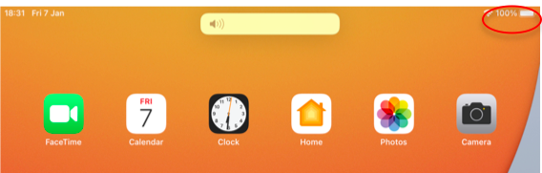

* When it is connected, it looks like this:

|  |
| --- |
|  |



* When it is not connected, the symbol will disappear:



|  |
| --- |
|  |

### In this case, the Wifi will need to be turned back on. Bluetooth must be turned on also to ensure smooth connection between your devices and Ipad (there is no symbol on the Home Screen to indicate whether or not Bluetooth is on, therefore it must be checked using the steps outlined below). The researcher will ensure that both of these are on when you provided with your ipad, however in case they get turned or you are experiencing internet connection issues, you may need to check and subsequently connect both, using the steps outlined below.

### Turning on your Wi-Fi & Bluetooth

* Wake up your iPad (see “Putting you iPad to Sleep and Waking it Up” above).
* Place you finger on the top right hand corner of the screen, where the battery and wifi icons are.
* Like when shutting off the iPad, swipe your finger up towards the top of the screen (again, like your checking for dust or running your finger along a steamy mirror).

|  |
| --- |
|  |

* **You will be presented with the following screen:**

|  |
| --- |
|  |

* **Look for the box at the top of the screen that contains the Wi-Fi and Bluetooth icons.**

|  |
| --- |
|  |

* **Both of these icons should be blue:**

|  |
| --- |
|  |

* **If they are not, it means that your Wi-Fi and Bluetooth are not turned on and will look like as follows (simply tap them to turn them on, they will appear blue as above once on).**

|  |
| --- |
|  |

|  |
| --- |
|  |

### Battery

* This icon tells you have much power is left in the battery of your iPad.
* When this percentage begins to get low, you will need to charge your iPad (see “Charging your iPad”).
* The colour of the battery will change from green to red to alert you to charge it.

|  |
| --- |
|  |

## 1.6 Putting your iPad to sleep and waking it up

* You will not be using your iPad all day and at times it will be in the corner of the room or on a table somewhere.
* In times like this, the Home screen will go dark.
* To wake it up, press the Home button twice with a slight pause (2 sec) in between presses.
* After the first press the screen will light up, displaying the time.
* After the second press, you will be.
* When you are done using the iPad and you want to darken the screen again simply close the case.

If you do not want to close the case, preferring to let the iPad stand or you are not using the case at all, locate the power button (Section 1.2) and give it a short press. This will darken your screen.

## 1.7 Turning off your iPad by mistake

* It is not necessary to turn your iPad off, putting it to sleep will suffice.
* Sometimes however, when putting it to sleep, you may keep the Power button pressed for too long and be greeted with the “Turning Off” screen:

|  |
| --- |
|  |

* You will see a cancel button at the bottom of the screen:

|  |
| --- |
|  |

* Tap Cancel on the screen.
* This will bring you back to the bright screen once again.
* At the top of the screen, you will see a “slide to power off” button.

|  |
| --- |
|  |

* On the rare occasion that you wish to turn off your iPad, for example, if you were taking it on an airplane.
* Place your index finger on the white circle and slide it to the right, keeping your finger on screen while sliding.
* Picture running your finger along a shelf, checking for dust or running your finger along a steamy mirror.
* When you wish to turn it back on again, follow the points in “Turning on your iPad” above.

## 1.8 Charging your iPad

* Charing your iPad is very similar to how you would charge a mobile phone.
* Your iPad can be on or off when charging, i.e. if your battery dies you can plug the iPad into charge.
* Plug the charger, provided with your iPad, into a power socket.
* Then insert the other end of the charger directly into your iPad.
* Where you plug it in is located on the edge of the iPad, just beside the Home button.

|  |
| --- |
|  |

|  |  |  |
| --- | --- | --- |
| * When the battery is charging, a shape like a lightning bolt will be displayed on the battery icon.      * If your iPad is completely out of battery when you are charging it, you will still be able to check it is charging by pressing the home button once. The outline of an empty battery symbol will appear.  1.9 Volume Buttons  * As you will see in Section £, you will be able to listen to guided mindfulness audios using the ECME-ACT app. * Depending on where you are, you may wish to adjust the volume of these videos. * Just like the power button, there are Volume Up and Volume Down buttons on the edge of the iPad.  |  | | --- | |  |  * If you press these buttons you will see a volume bar appear at the top of the screen: * This will show you if you are turning the volume up/down.      |  | | --- | |  |  1.10 Before you move on to How to use your Devices  * While the next section will help you to use your other devices, it is important that you make sure that two things are always turned on: Wi-Fi and Bluetooth. * As stated, the researchers will ensure that these are turned on for you on their first visit. * However, if for some reason they get turned off, the following steps will outline how you would turn them back on again: |

## How to Use your Devices

Now that we have covered how to use your iPad and, it’s time to move on to your other devices. You will have received a Withings Smart Watch and Blood Pressure Cuff. In this section we will describe how you use the devices and also how you ensure that they are sending the information to the iPad.

Some participants will use their own devices (e.g. blood pressure cuff), as discussed with the researcher. If that is the case, please refer to Section 3.5, “Add Info”, where we will outline how you can manually enter your readings into the ECME-ACT app

# How to Use your ProACT App

Before explaining how to use your devices, we will briefly introduce you to the ECME-ACT App. See this app as the place where all of your data, that is, all of your measurements and readings live, where you will complete your daily questions, view your ACT tips, and listen to mindfulness audios (discussed in more detail later)

To begin, open the ECME-ACT app on your iPad. We have circled it in the following picture, in red.

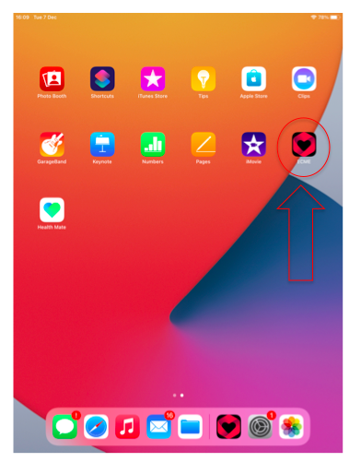

|  |
| --- |
|  |

## Opening ProACT – Your PIN

* When you press the ProACT App on your iPad, the first thing that you will see is the following screen:

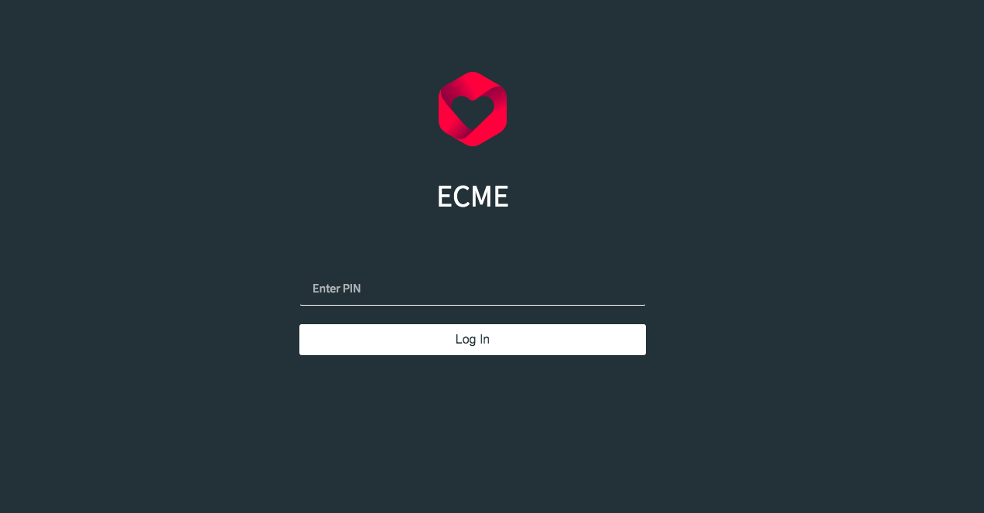

|  |
| --- |
|  |

* This is where you enter the PIN code that we gave you.
* Simply press the numbers that correspond to your PIN and press “Log In”.
* You will be brought to the Home Screen.

## 3.2 The Home Screen

* When you enter the ECMEACT App, the first screen that you will see is called the Home Screen. It will look like this:

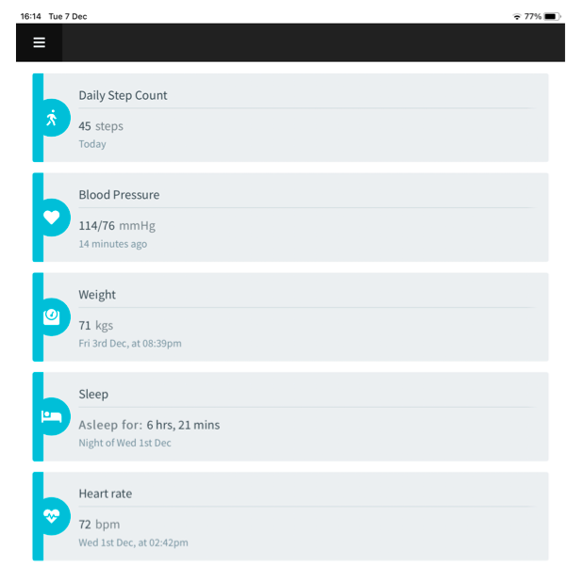

* Your dashboard displays your most recent readings for the following health metrics: Daily Step Count; Blood Pressure; Weight; Sleep; and Heart rate.
* At the top left of the screen, you will see three vertical lines (See picture below). 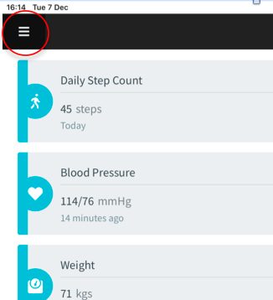
* By clicking on these lines, you will be brought to your “Overview” dropdown menu of further options (See below). We will go through what each of these means in further detail as we progress through the different devices and features of the app which you will be using.

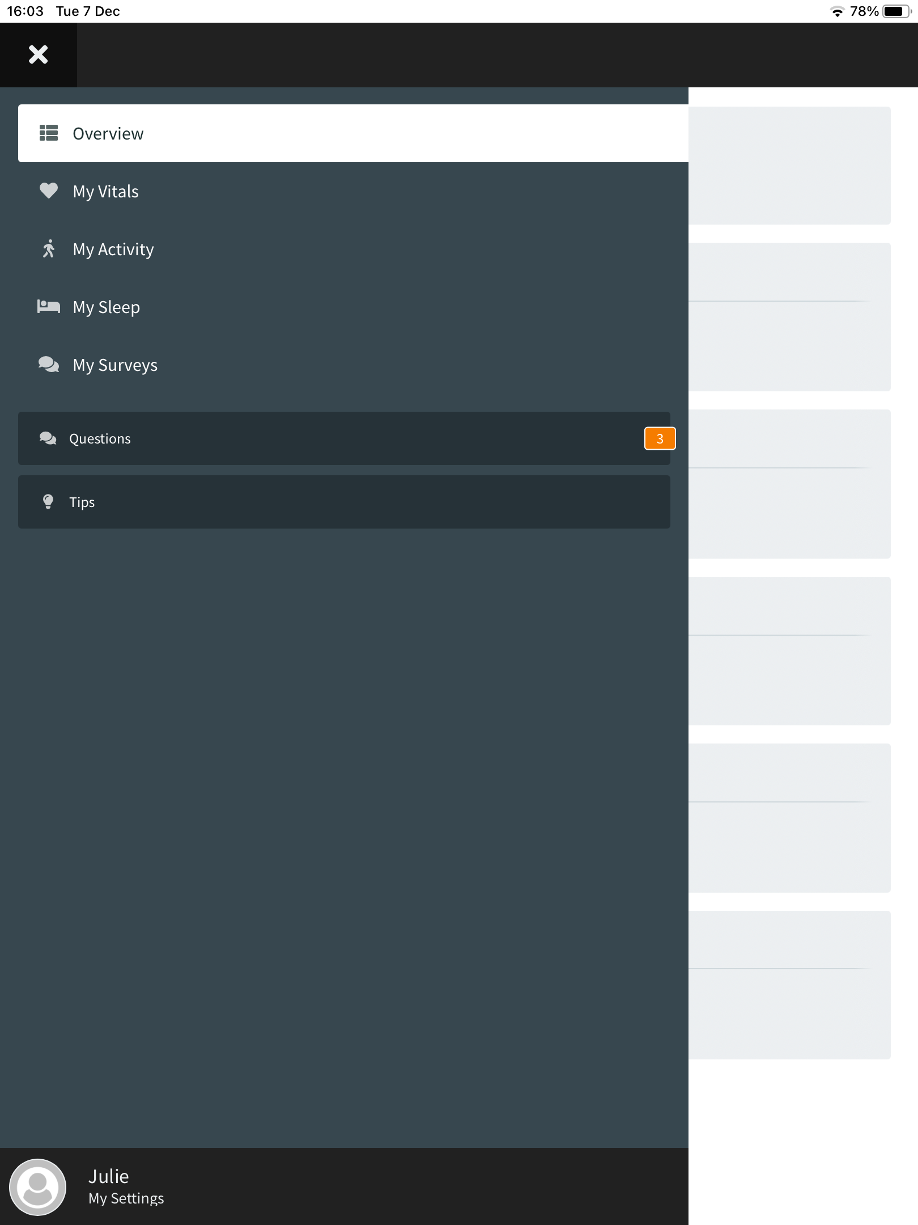

## 2.1 WithingsSmart Watch

Your Withings smart watch looks like and is worn exactly as a normal watch. However, it can do a lot more than tell you the time! When you are wearing the watch it can track your activity, including the distance you walk and how many steps you take in a day. It can track your sleep, and will tell you the time you spend awake, the time you spend asleep and how often you wake up at night. It is waterproof and can be worn all the time, even in the bath or shower.

For the watch to work all you really have to do is wear it!

|  |
| --- |
| OKIA Withings Move ECG white-blue - iPon - hardware and software news,  reviews, webshop, forum |

However, to see and keep track of your activity and sleep overtime you will also need to use your ECME-ACT app.

**Activity**

* To track your daily step count, you must select the “Activity” tab on the Overview Dropdown menu described on the previous page.

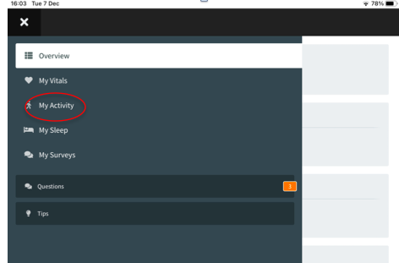

* Once you click the “My Activity” icon, you will be brought to the following screen.

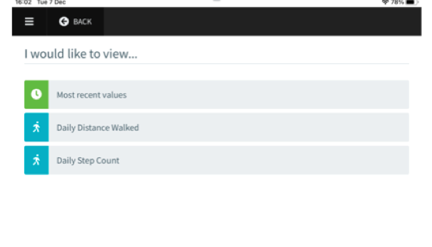

Select “Most recent values” to view the latest Daily Distance Walked and Daily Step Count readings from Withings Smartwatch. They will be displayed in the following screen:

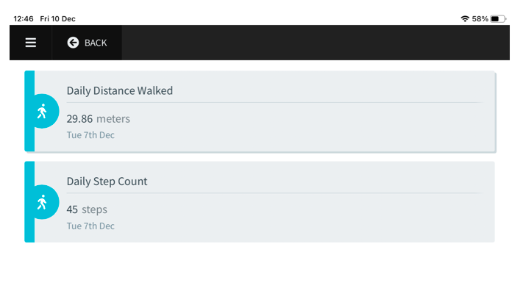

Your ECME-ACT app will keep a log of your progress as long as you are using your Withings Smart Watch, meaning you may go back and view readings from a specific day, week, or month. This feature can be especially helpful in allowing you to track your progress and increase your awareness of any patterns, changes etc. To view the log as measured in terms of distance walked, select “Daily Distance Walked”, and you’ll be brought to the following screen:

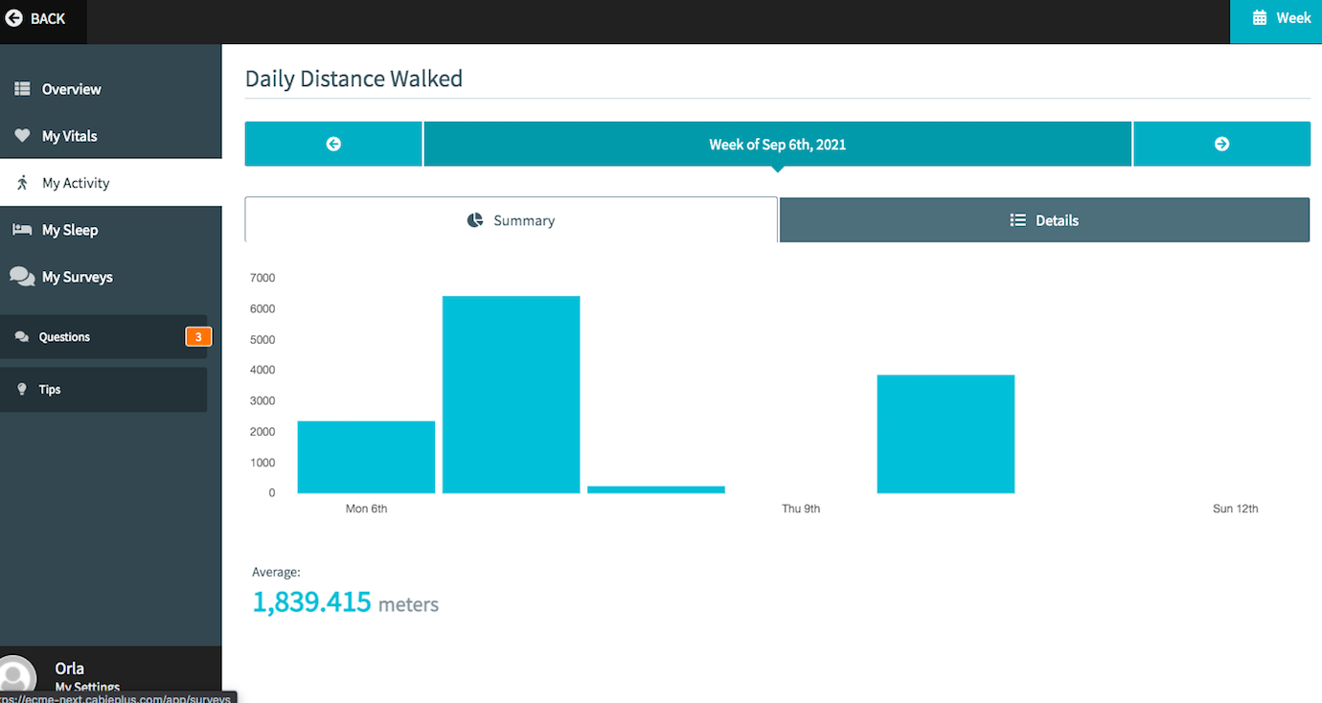

Similarly, view the log as measured in terms of the number of steps you’ve taken, select “Daily Step Count”, and you’ll be brought to the following screen:

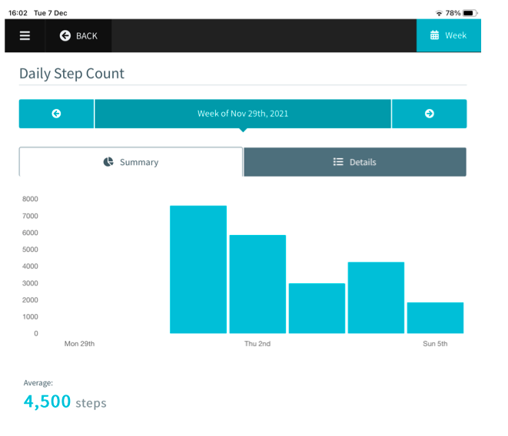

To view a past reading, depending on whether you wish to view a previous week or month, ensure the icon in the top right hand (See below), reads “Week” or “Month” (and if it’s not set to the one you want, simply click to switch!)

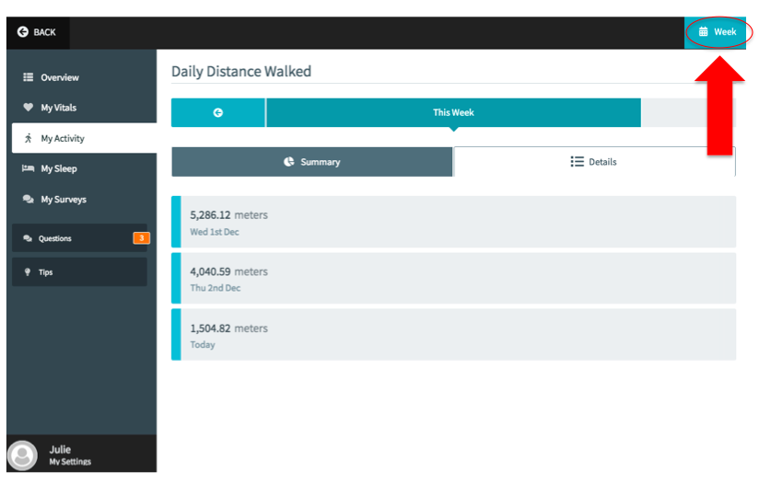

To view previous weeks or months, click the arrow just under the “Daily Distance Walked” screen title (see below).

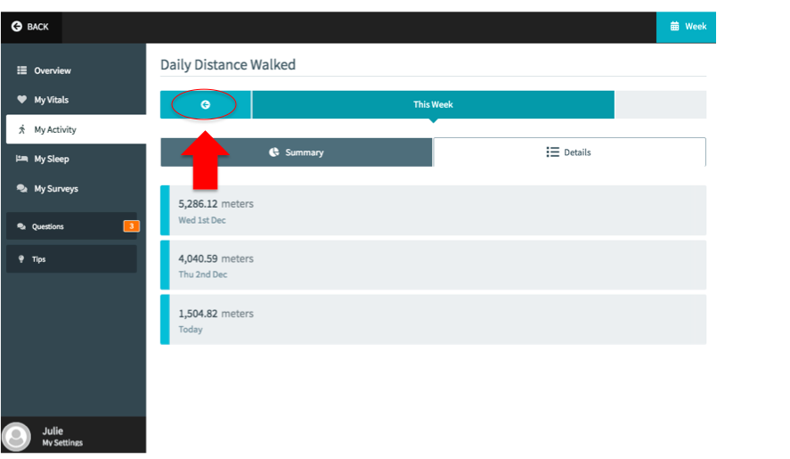

Finally, if you wish to switch the display styles from the detailed summary outlining your metrics each day as pictured above, to a visual summary using graphs (see below), simply click the “Summary” tab highlighted below (and likewise click “Details” to switch back again).

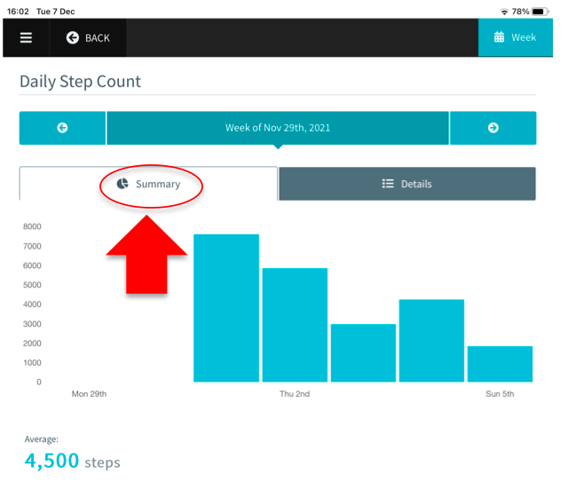

* Remember your most recent daily Step Count will also show up automatically on your Dashboard when you log into the app.

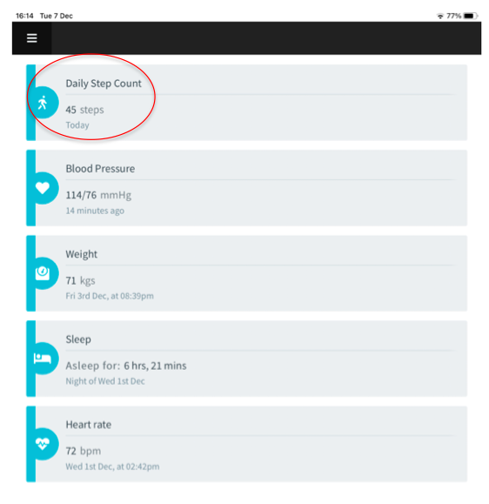

* By clicking on the icon, you will be given a breakdown containing further details of Step Count and Distance (See below).



**Sleep**

* Tracking your sleep is very similar to how you track your activity. Go to the same dropdown menu as before, and select the “My Sleep” (see below)

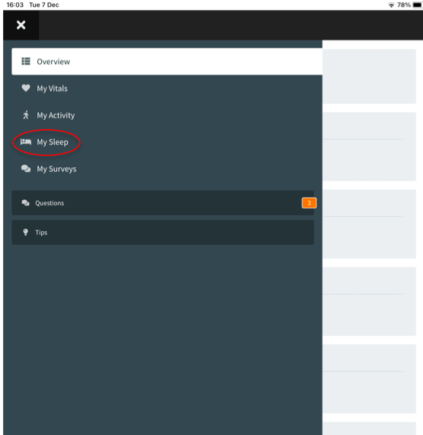

* The following screen will be brought up. As with your activity log, your ECME-ACT app will keep a log of your sleep as long as you are using your Withings Smart Watch, meaning you may go back and view readings from a specific day, week, or month. This can allow you to track how many hours of sleep you are getting each night as well as how much time you spend in deep and light sleep. Details are also given on how much time you spent awake in bed.

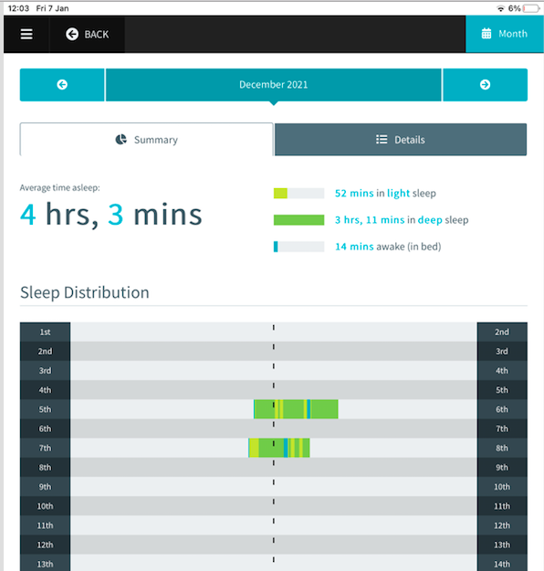

As with activity, to view a past reading, depending on whether you wish to view a previous week or month, ensure the icon in the top right hand, reads “Week” or “Month” Finally, if you wish to switch the display styles from the detailed summary outlining your metrics each day as pictured above, to a visual summary using graphs (see below), simply click the “Summary” tab highlighted below (and likewise click “Details” to switch back again).

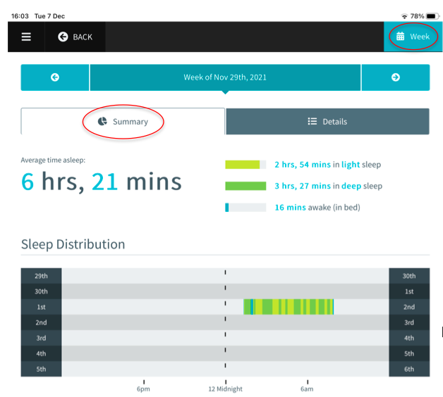

* You can also see your most recent sleep value on your dashboard when you first log into the app.

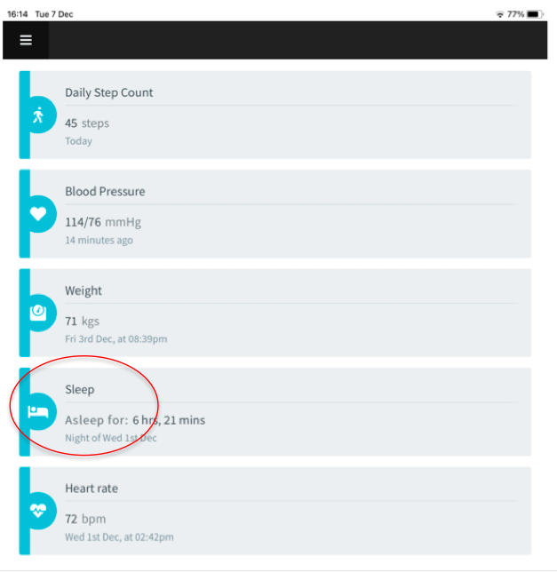

* By clicking into the sleep icon on your dashboard, you will be brought to a screen containing a breakdown of your night’s sleep, including deep sleep, light sleep, and time spent awake (See below).

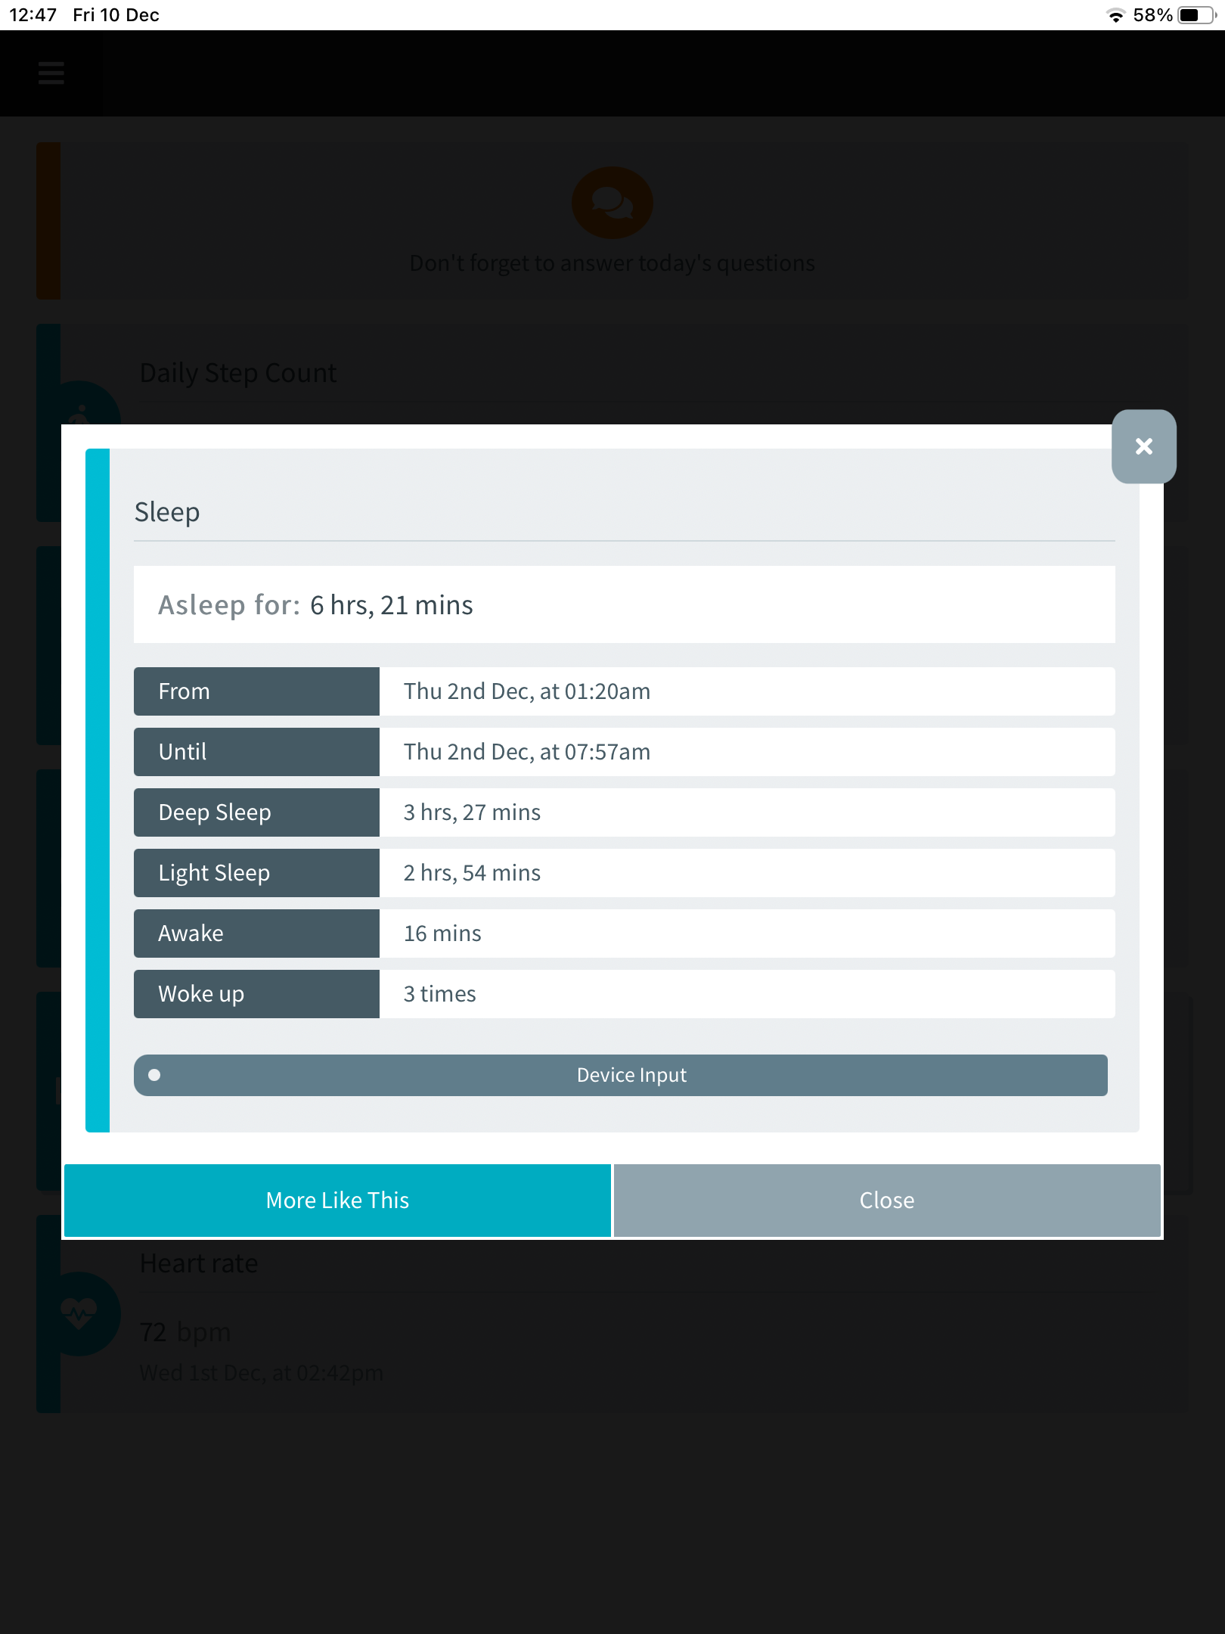

**Note:** Sometimes this readings might not appear right away (sleep in particular may take over a day to show up!), in which case you should my need to check your Withings App (Details are provided below on how to check and ensure readings are syncing from your Withings app). However if you have checked Withings are continuing to experience considerable delays, please contact the researcher.

## Withings Blood Pressure Cuff

Your Withings Blood Pressure Cuff can be used to measure and monitor your blood pressure and your heart rate. (If you are using your own Blood Pressure Cuff as directed by the researcher, you should skip to the **Manual Input** section below). To use it, you will also need your iPad. You should be seated comfortably with your arm relaxed by your side.

|  |
| --- |
|  |

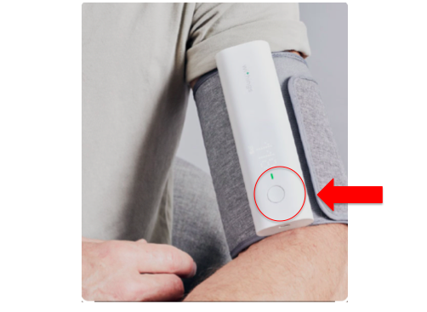

* Then take the blood pressure cuff and open the Velcro strap. You will see on one end of the cuff there is a small button (outlined in red above), don’t press it yet. Loosen the cuff and slide your arm into the cuff. Then tighten the strap so that it is securely on your arm. This step is important, if the cuff is too loose it will be hard to take a reading. ROLL UP YOUR SLEEVE- this step is also very important as if you try you use the cuff over your sleeve it will lead to inaccurate readings.
* Once the cuff is comfortably and securely on, reach across and press the button at the top of the cuff. You should be sitting relaxed and comfortable, with the cuff at the same level as your heart, and your arm resting flat on a table or arm rest.
* Your cuff will then start to inflate and feel tight around your arm and the numbers on screen will start changing. This will last between 30-60 seconds. It feels just like the normal blood pressure cuff your GP might use.
* When the reading is finished you will feel the cuff loosen.
* Your readings will appear in your dashboard of the ECME-ACT app on you iPad, under Blood Pressure and Heart Rate. They will be marked with the day and time they were taken, therefore, if they do not read the time at which they were taken, allow a few minutes for syncing (if there is a considerable delay in your readings showing up, you should consult the Withings App as Outlined below).
* Your Blood Pressure Reading will show two numbers. The first number will be a larger number, this is the Systolic number. The second number will be a smaller number and that is your diastolic.
* Your heart rate will be given in beats per minute (BPM).

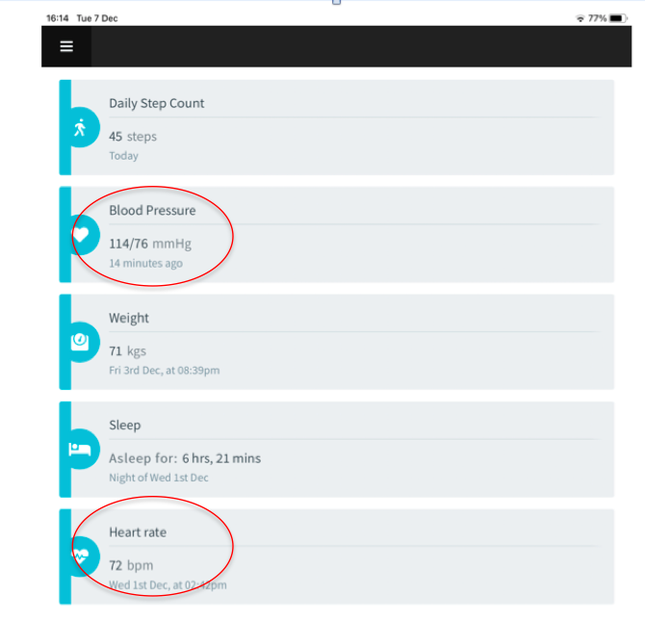

**Note:** The device is set to take one blood pressure reading however if you press the button twice it will change to take 3 consecutive readings and provide you with the average of the three. Taking one reading is sufficient however.

**Manual Input**

If the researcher has directed you to use your own Blood Pressure Cuff, you will be required to manually input your Blood Pressure and Heart rate readings. This process is very straightforward and is outlined step-by-step below.

* Firstly, go to the Overview Dropdown menu, and select “My Vitals” as shown and the screen shown below will appear.

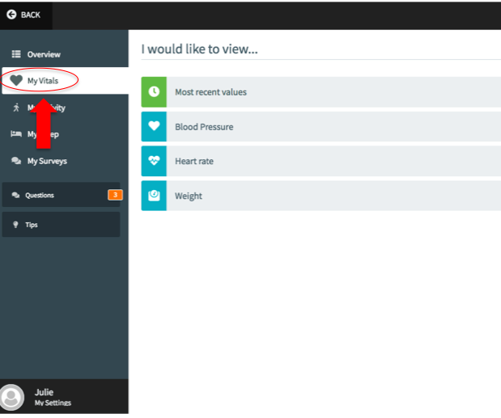

* Once you have clicked on either the “Blood Pressure” or “Heart rate” tab, depending on which you wish to input, one of the following corresponding screens will appear. From here, you should select the “Manual Input” button as highlighted for each.

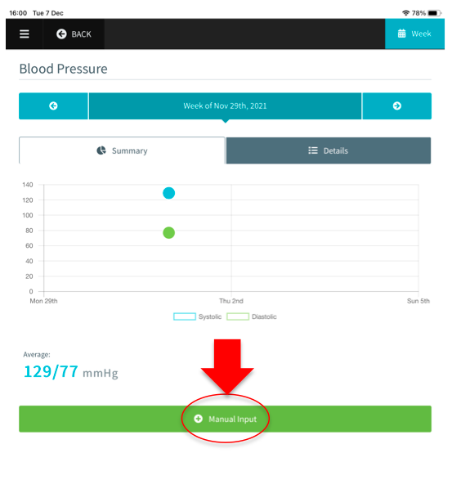

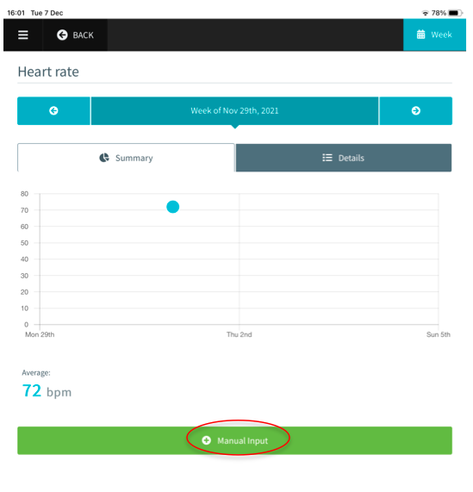

For **Blood Pressure,** you will be brought to the window shown below. Using your own Blood Pressure device, simply take a reading as you normally would and enter the values given into the respective boxes. When you have done so, you may select “Save Value”.

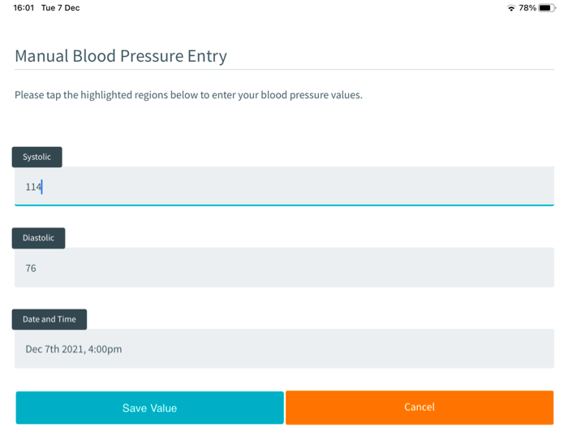

After selecting “Save Value”, the following screen will pop up asking you to confirm that the value you entered is correct and that you are happy to save it. Once you select “Confirm”, the reading will be saved in your ECME-ACT app along with the date and time at which it was imputed.

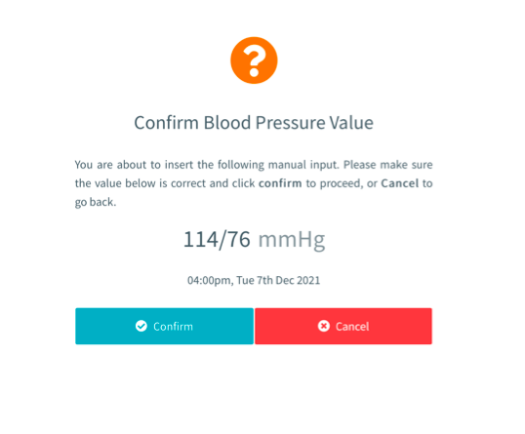

* Likewise for **Heart rate, you will be brought to the window shown below. Using your own device, simply take a heart rate reading as you normally would and enter the values given into the respective boxes. When you have done so, you may select “Save Value”.**

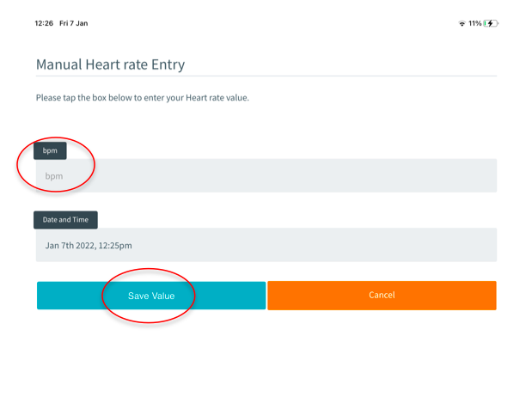

After selecting “Save Value”, the following screen will pop up asking you to confirm that the value you entered is correct and that you are happy to save it. Once you select “Confirm”, the reading will be saved in your ECME-ACT app along with the date and time at which it was imputed.

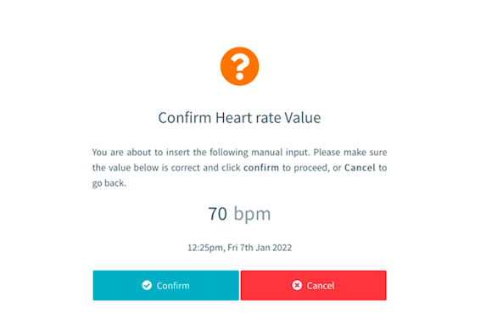

The following screen will appear indicating that the entry has been successfully saved.

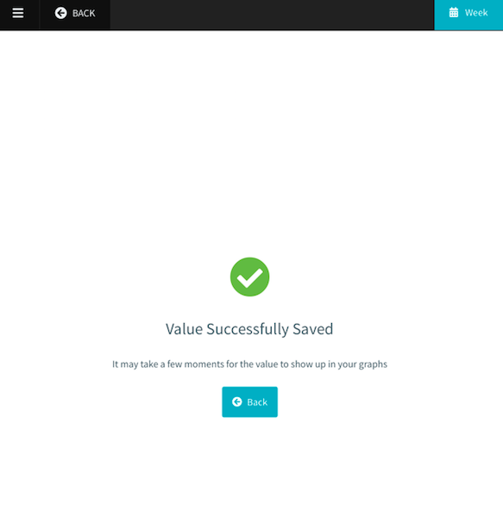

**Tracking health readings**

* As with your activity and sleep readings, your ECME-ACT app will keep a log of your readings each time you use your blood pressure cuff. It will record your blood pressure and heart rate readings and the date and time at which they were taken (See below).
* In order to view your readings, go to the Overview Dropdown menu, and select “My Vitals” as shown.



* Here you may view your readings, just as with your Activity and sleep, you can see your most recent values for your various health readings by selecting “Most recent values” as shown below.

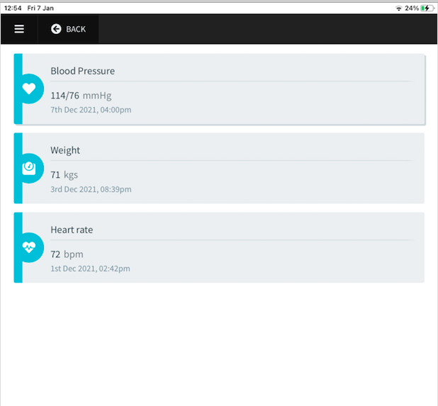

* As with your activity and sleep log, your ECME-ACT app will keep a log of your Blood Pressure and Heart Rate readings as long as you are using your Withings Blood Pressure Cuff (or entering these values manually), meaning you may go back and view readings from a specific day, week, or month (See below)

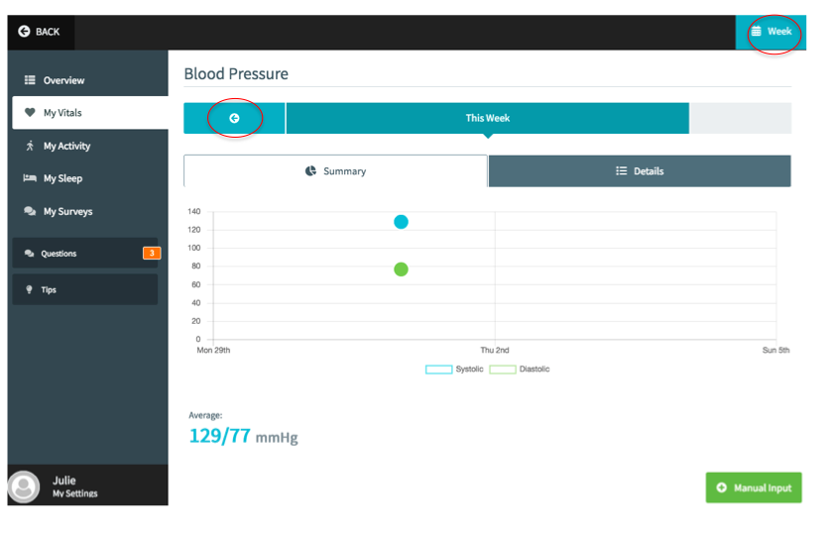

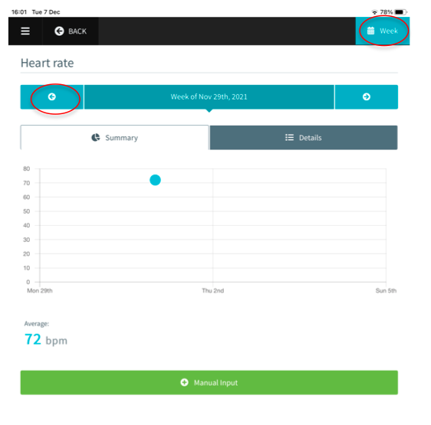

As with activity, to view a past reading, depending on whether you wish to view a previous week or month, ensure the icon in the top right hand, reads “Week” or “Month” Finally, if you wish to switch the display styles from to a visual summary using graphs as pictured above

the detailed summary outlining your metrics each day (see below), simply click the “Details” tab highlighted below (and likewise click “Summery” to switch back again).

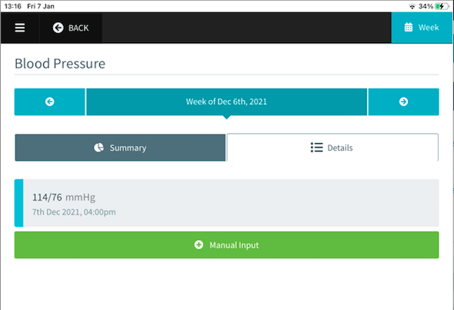

|  |
| --- |
|  |

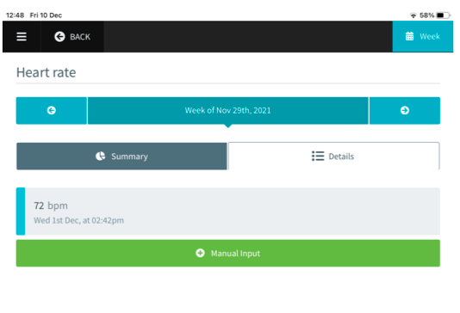

**Note:** You may also manually input your weight by selecting the “Weight” option on your Dashboard. The steps are then identical to those outlined above for Blood Pressure and Heart Rate. However, monitoring weight is completely optional in the present study. You should only input and monitor weight if you feel it would be beneficial to your condition management and/or your doctor has recommended that you do so.

## Syncing with Withings App

In order to ensure your ECME ACT app is running as smoothly as possible and that your readings are being updated as promptly as possible, you may also need to access the Withings app on your ipad as shown below. The Withings app is the host for your Smartwatch and Blood Pressure Cuff (unless using your own) and feeds your readings directly into the ECME ACT app platform.

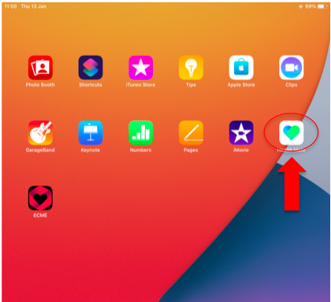

Firstly, click the Withings Icon as shown below

Once you have clicked this, you will be brought to the screen shown below. At the bottom of this screen, select “devices”

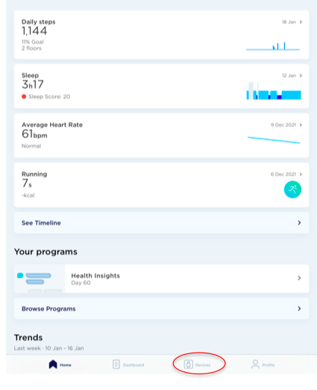

Here you will see all the devices that are connected to your Withings account (i.e. your watch and BP cuff if not using your own). Click on the picture of the device you want to check (Also make sure you have your device close to your ipad to ensure a good connection).

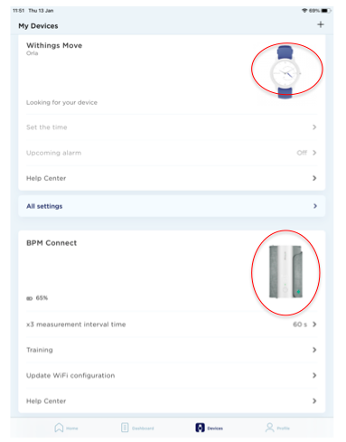

From here you will see:

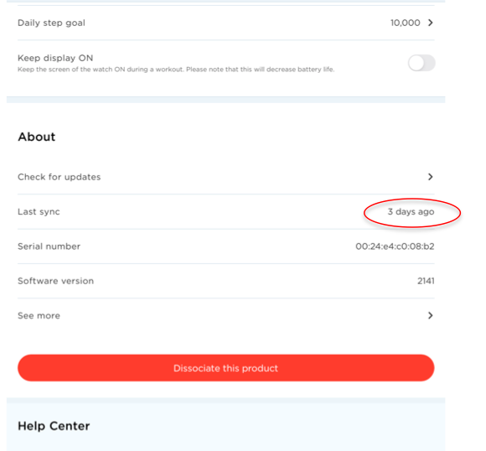

Sometimes there may be a slight in the time taken for the most updated readings

If you are experiencing connectivity issues:

-Ensure that your Wifi and Bluetooth are connected

-Turn your ipad off and on again

If these steps are unsuccessful, or you encounter difficulty at any stage, you may also contact the researcher (redacted for Blind Review) Monday to Friday; 10am-6pm) who can talk you through the steps to troubleshoot and address any issues.

Note: You must not log out of Withings account. If you log out of your Withings account by accident, please contact the researcher

From the purposes of this study, we only provide instructions on how to measure sleep, activity, Heart rate and Blood Pressure (unless using your own device), however if you wish to explore more functions of your Withings device, details on how to do are provided at https://www.withings.com/ie/en/

## 2.6 Charging the Batteries in your Devices

When we provide you with your devices, we will ensure that they are fully charged. The batteries in your Withings Smartwatch and Blood Pressure Cuff should last a long time (you may only need to charge them once or twice over the course of the trial!), but for the times when you will need to charge them, you will need the use the cables given to you also with the devices (See images below).

Both cables are standard USBs and can therefore, we used in your Ipad charger once you switch out the cable (see below). In general, always feel comfortable contacting the researcher (087 7920515) to report any issues that you are experiencing with your devices, which includes letting us know if you are experiencing any difficulties around charging your devices.

|  |
| --- |
|  |

## Your Daily Questions

As well as taking health and activity readings, another important aspect of the ECME-ACT is tracking your psychological well being on a daily basis through your daily self-report questions. These questions should be completed every day and it is important that you complete all three. You will receive a text message from the researcher reminding you to do so (they should not take more than a few minutes to complete!)

To view your view questions, you should go to the “Overview” Dropdown menu as shown below. You will also be shown a reminder at the top of your Dashboard as shown if you have not yet completed your questions for the day.

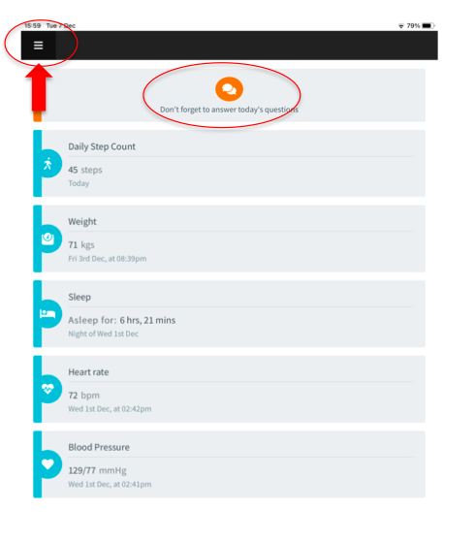

You should then select the Questions tab as shown below (there will be a an orange box with the number 3 in it if you have not completed your questions).

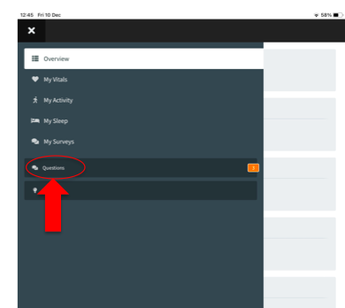

You will be brought to each of your questions individually on their own screen as shown below.

Specific details on how you should answer each question are provided below. For answering all of them, it is important that you consider each question carefully in the context of **the day on which you are answering.** For each question, you should drag the slider along and place your circle closest to wherever you feel you fall between the options.

Try to answer as honestly as possible. Don’t worry if you find that your answers differ quite a bit from day to day, or by the same token, if you feel that your answers are not noticeably changing. All humans have different and varied experiences in how they feel day to day, so all types of responses are normal (it would be very boring if we were all the same after all!)

A. “**Struggling with my thoughts, feelings, or physical sensations**” **(1)** through to **“Open to my thoughts, feelings, or physical sensations”(10).** When struggling with our thoughts, feelings, and physical sensations we spend a lot of time, attention and energy trying to distract ourselves from them and make them go away, especially if they are unpleasant. When Open to our thoughts, feelings, and physical sensations, we are allow them to come and go and do not try to get rid of them, even if they are unpleasant.

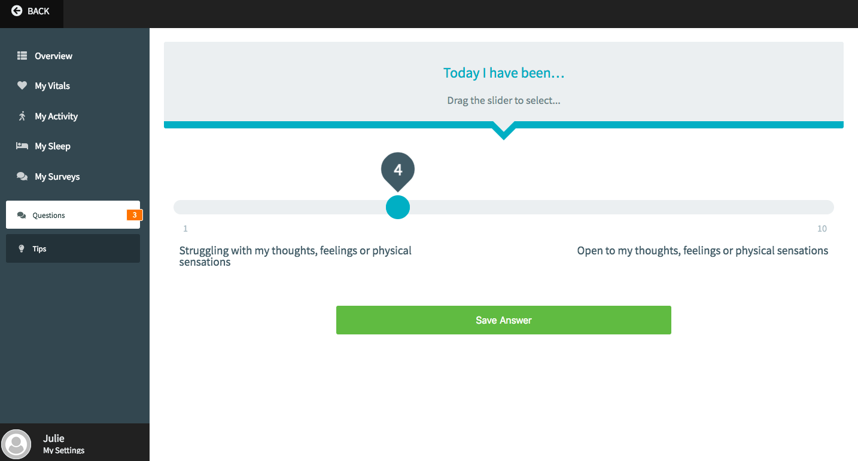

B. **“Not pursuing things that matter to me”** (1) through to “**Pursuing things that matter to me”** (10). This “things that matter to me” in this question, simply refer to the things that give our lives joy and meaning (e.g. spending time with family and loved one; engaging in hobbies that we enjoy; helping out others etc.).

When we pursue these things, we devote time to these things and see them reflected in our daily actions. However when we are not pursuing them, we do not dedicate as much time or behaviour to these things as we wish to.

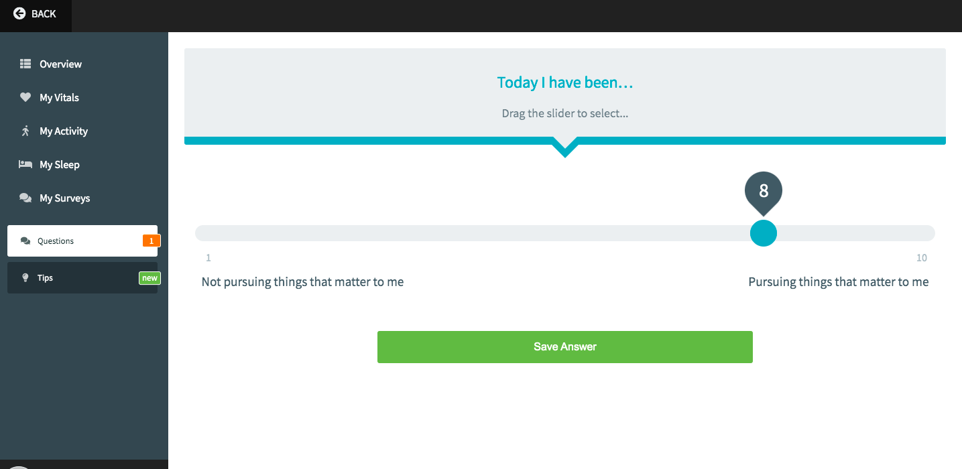

C. “**Acting without Awareness”**(1) through to “**Acting with Awareness”**(10). When we are Acting Without Awareness, it means that we distracted and not paying attention to what’s going on moment to moment in everyday life. On the other hand, when we are Acting With Awareness, we are present, aware and pay attention to what’s going on around in in day-to-day life.

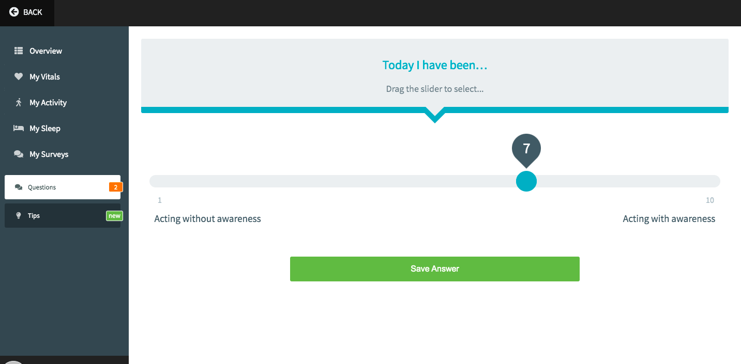

**Daily Questions Summary**

Just as you did with your Lifetstyle, Heart rate, and Blood Pressure readings, you may view your progress over time on your daily questions in the ECME-ACT app. By selecting the “Surveys” tab in the Overview dropdown (See below). You will be able to be able to view graphs of the number of times you selected certain responses, in a specific week or month (See previous sections for details on how to switch from Week to month etc.)

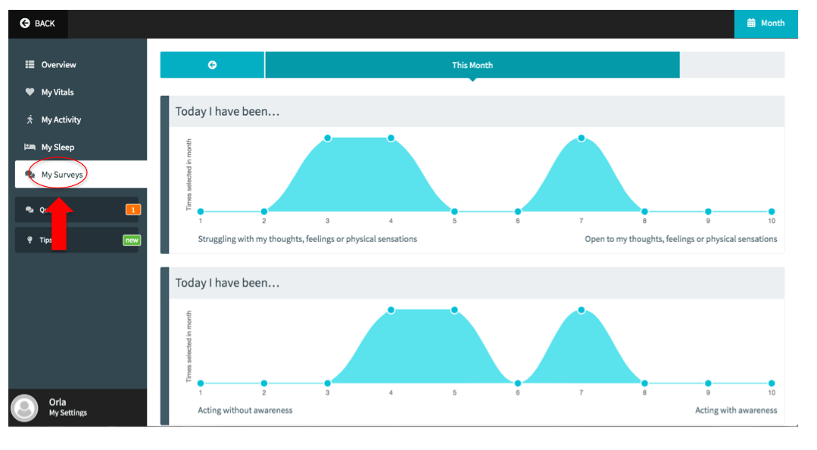

## Psychology Tips and Mindfulness

Another key feature of the ECME-ACT app and one of the most important features of the overall trial is your psychology tips and mindfulness exercises. These will complement your one-to-one therapeutic sessions and each tip/mindfulness package will be made available to you after you complete each therapeutic session. To access them, you must select the “Tips” tab from the “Overview” dropdown menu.

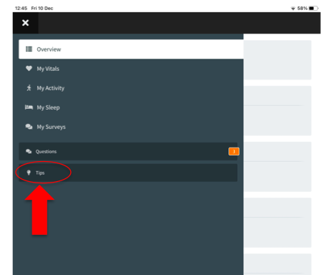

As mentioned above, these tips will become available as you progress through the trial, when you first begin using the ECME-ACT app this section will be blank. However, once you have completed your first therapeutic session, the following screen will become available under “Tips”.

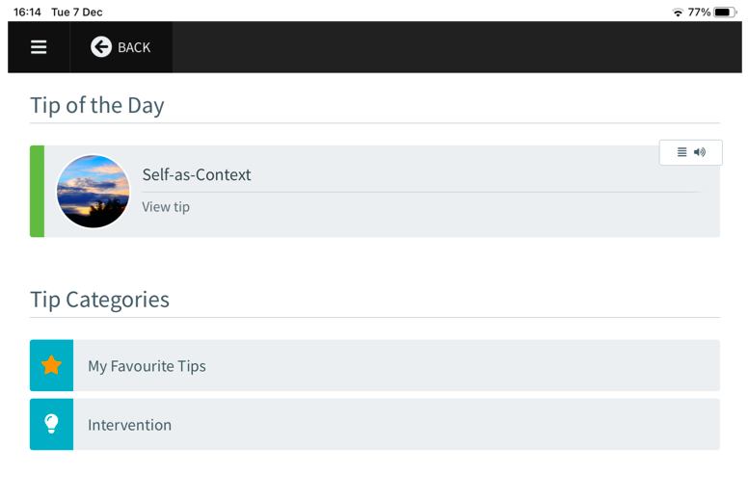

Your “Tip of the day” will refer to the tip made most recently available (i.e. the one corresponding to the most therapeutic session you completed). Under “Tip Categories”, you will see, “Intervention” wherein you can access the full list of Tips available over the course of the intervention, as you complete each of your sessions (see below). There is also a “My Favourite Tips” categorically where you may save any tips which you want to access quickly (Explanation on how to add Favourite Tips is provided below).

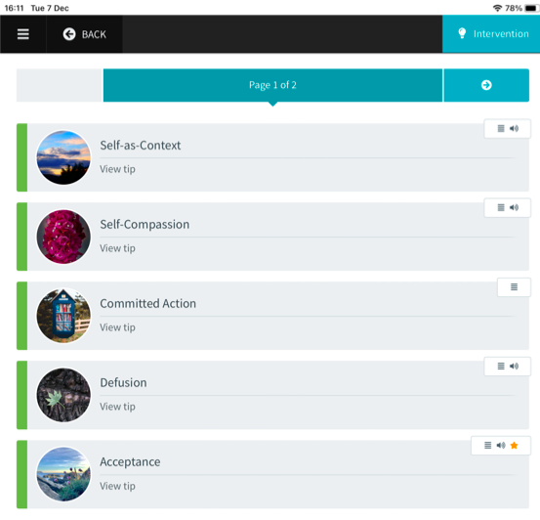

Each tip will contain some written text, including a brief explanation and summary of what was covered in your therapeutic session, as well as, tips on how to implement the strategies learned into daily life. For a number of these tips, there will also be an accompanying guided mindfulness audio. You can switch from the written text to the audio using the tabs just above the text (See below). **Remember to check this tab for the “Audio” option.**

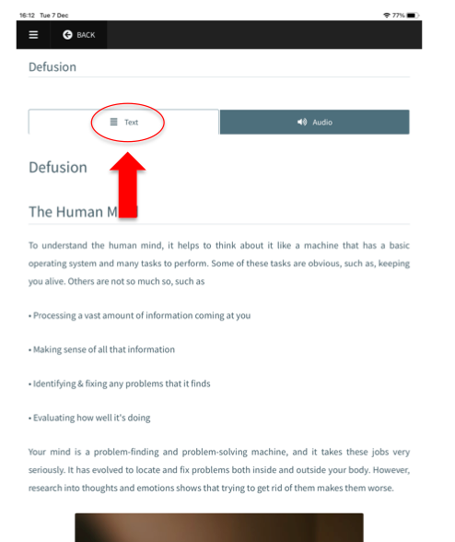

When you select the audio tab, you will be brought to a screen like the one shown below. You can simply select the play button as instructed and the guided mindfulness audio will begin to play. We advise that you listen to this somewhere quiet, where you know you will not be disturbed for approximately 15 minutes or so!

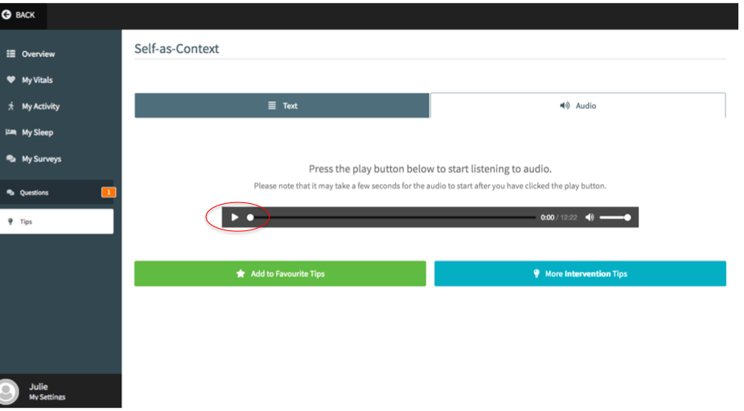

If you find any tips particularly helpful, you may add to them to “Favourite Tips”, where you can access them easily when first enter the tips screen.

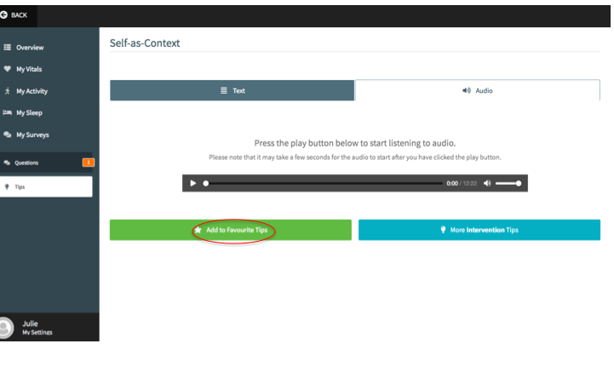

## Zoom

As discussed with the researcher, your one-to-one therapeutic session will take place using the video-conferencing technology platform Zoom. The researcher will contact you with details of the day and time of your sessions, however if there is any issue with attending your session, it is important that you let the researcher know as soon as possible (redacted for Blind Review). The researcher will email you further details on how to attend your Zoom but we’ve included some basics below. Your ipad will come with the Zoom app installed, and you will need to select the icon soon below to access the session using your ipad.

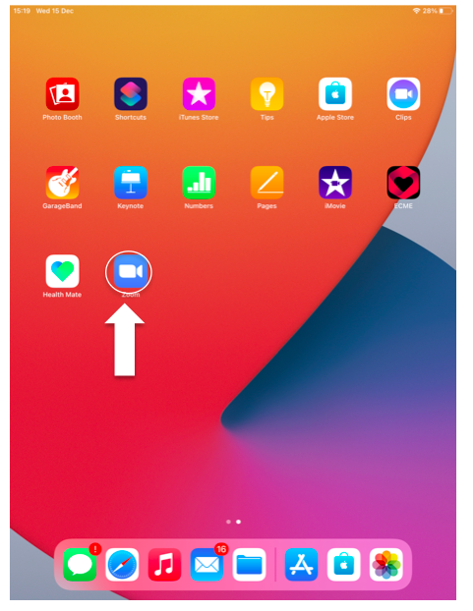

Upon clicking into the Zoom icon, you will see the following screen. The researcher will send you the details you need to join by selecting “Join with a personal link name”. You should also ensure that “Don’t Connect To Audio” and “Turn Off My Video” under “Join Options” are in the off position (as shown below), in order to ensure that your sound and video are on when joining the call.

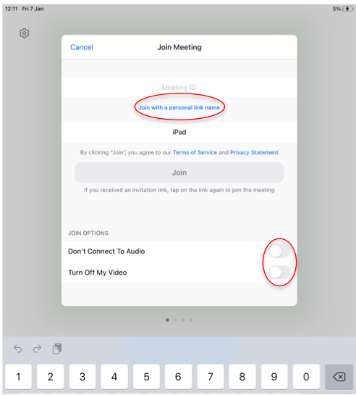

## Ending Session

When you are done with using your ECME-ACT app for the day, there is no need to specifically close the app as once you put your ipad to sleep, the session will time out automatically.

However, if for any reason you do wish to manually end your session without waiting for it to Time Out (e.g. if you are experiencing issues as outlined in the next section), go to “My Settings” at the bottom of your overview tab (see below)

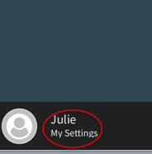

From here, you will be brought to a page with various settings as shown below (we advise that you do not adjust these and they may create issues with display, however if you wish to do so, please contact the researcher). At the bottom of the screen, under “Account” you will see a blue “End Session” button. Select this to end your session. **NB do not select “Log Out” option (orange button)** as doing so will mean that you will need to contact the researcher in order to fully log back in.

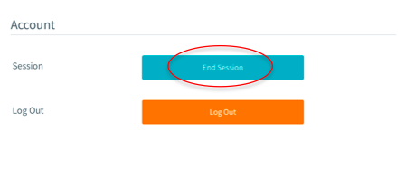

## If Issues Arise

While the devices and app selected for this trial are high quality and have been rigorously tested, from time to time technology will sometimes glitch and create issues. Thankfully, most issues may be quickly and easily rectified!

* If you are experiencing issues ECME-ACT app or it seems to be running slower than normal, we advise that you “End Session” as outlined in the previous section, waiting a few minutes, and re-entering your PIN (as shown in Section £).
* If this does not change anything, we suggest turning your ipad off, waiting a few minutes, and turning it on again (as shown in Section £)

If you have tried both of these options, and/or you are experiencing issues with your Withings Smartwatch or Blood Pressure, you will need to contact the researcher as a factory reset may be required. If you are experiencing issues with either of these devices, please contact (redacted for Blind Review) (10am-6pm). The researcher may need to arrange a Zoom call to identify what issue is present and how best to address it.